Unit Test Plan

1. Module Overview
Web application using Talkpush API for Campaign Creation, Candidate Creation, Retrieving Candidates and Shortlisting a candidate.

1.3 Logic Flow Diagram
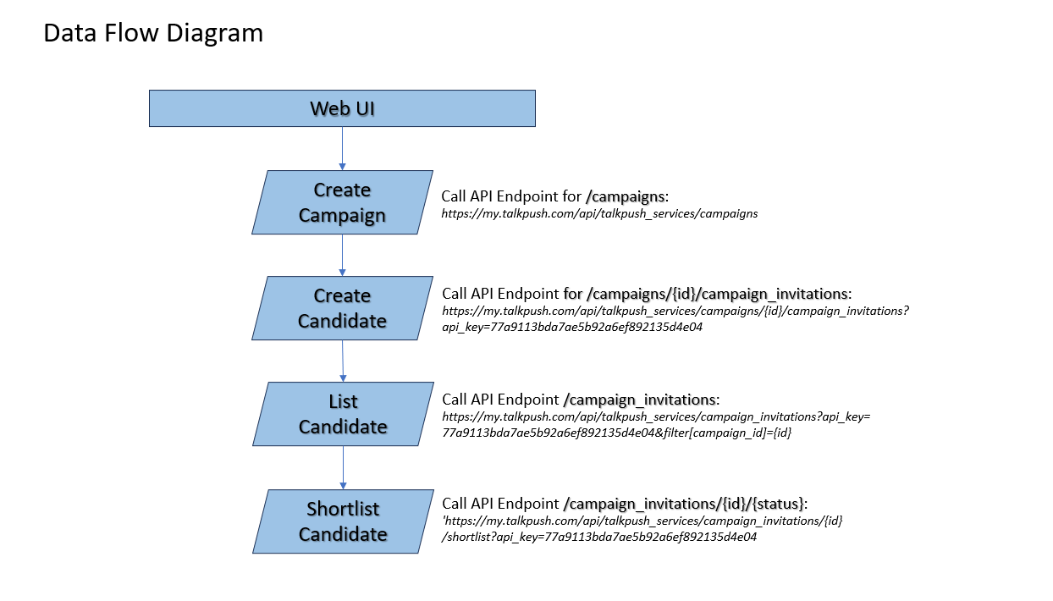

2. Test Data
- Creation of campaign.
APK key: 77a9113bda7ae5b92a6ef892135d4e04
Campaign title: < (e.g. "Alfred Talucod Campaign") >
Job Title: < (e.g. “Junior Software Developer”) >
Street: < (e.g. “Purok 2”) >
City : < (e.g. “Hagonoy”) >
Region: < (e.g. “Region III”) >
Postal Code: < (e.g. “3002”) >
Country: < (e.g. “Philippines”) >
Short Description: < (e.g. “Alfred’s Campaign”) >
Long Description: < (e.g. “Alfred Talucod Campaign”) >
Ats External ID: < (e.g. “at123”) >
Job Type: < (e.g. “Full Time”) >
Salary: < (e.g. “30000”) >
Salary Type: < (e.g. “Monthly”) >
Salary Currency: < (e.g. “Php”) >

- Creation of candidate.
First Name: < (e.g. “Alfred”) >
Last Name: < (e.g. “Talucod”) >
Email: < (e.g. “alfredtalucod@talkpush.com”) >
User Phone Number: < (e.g. “09123456789”) >
Source: < (string) >
Others: {}

- Retrieval of candidate.
APK key: 77a9113bda7ae5b92a6ef892135d4e04
Candidate ID: < (Provided by Campaign Creation) >

- Shortlisting a candidate.
APK key: 77a9113bda7ae5b92a6ef892135d4e04
ID: < (Provided by Candidate Creation) >

2.1 Positive Test Cases
Seq. No. | Test Condition | Expected Result | Passed / Failed
Campaign Creation
1. | All inputs are provided correctly. | Campaign created successfully | Y
Candidate Creation
2. | All inputs are provided correctly. | Candidate was successfully added to the campaign. Campaign ID: | Y
Retrieve a Candidate
3. | API key and Campaign ID was successfully fetched. | Table of all candidates in the campaign was showed successfully. Lead ID: | Y
Shortlist a Candidate
4. | All candidates in the campaign were successfully showed. | Candidate has been successfully updated. | Y

2.2 Negative Test Cases
Seq. No. | Test Condition | Expected Result | Passed / Failed
Campaign Creation
1. | API key provided is wrong. | An error “Invalid API key” was raised. | Y
2.a | Country is wrong. | An error “Country not found. These are the countries available for your company: Philippines” was raised. | Y
2.b | Country is blank. | An error “Country is required!” was raised. | Y
3. | Campaign ID provided is blank. | An error “Campaign name is required!” was raised. ” was raised. | Y
4. | Job Title is blank. | An error “Job Title is required!” was raised. | Y
Candidate Creation
5.a | API key provided is wrong. | An error “Invalid API key.” was raised. | Y
5.b | API key is blank. | An error “API key is required!” was raised. | Y
6. | Campaign ID provided is wrong. | An error “Campaign ID is required!” was raised. | Y
7. | First name, email, user phone number fields are blank. | An error “Validation failed: First name can't be blank, Email can't be blank, User phone number can't be blank” was raised. | Y
8. | First Name is blank. | An error “Validation failed: First name can't be blank” was raised. | Y
9. | Email and user phone number is blank. | An error “Validation failed: Email can’t be blank, User phone number can’t be blank” was raised. | Y
10. | Email provided is wrong. | An error “Validation failed: Email Invalid email” was raised. | Y
Retrieve a Candidate
10. | API key provided is wrong. | An error “Invalid API key” was raised. | Y
11. | Campaign ID provided is wrong. | An error 400 was raised. | Y

3. Interface Modules
API Type | API URL | API | Description
POST | https://my.talkpush.com/api/talkpush_services/campaigns | /campaigns  Create a new campaign inside your Talkpush account | This endpoint lets you create a new campaign inside Talkpush. Not all the information required to set up a fully operational campaign can be provided via the API. Permission settings, questions, message, smart filters and notifications need to set up from the campaign settings inside the CRM.  A common use case for this endpoint would be the automatic creation of a campaign inside Talkpush when a user creates a job requisition inside an integrated ATS.
POST | https://my.talkpush.com/api/talkpush_services/campaigns/59/campaign_invitations?api_key=77a9113bda7ae5b92a6ef892135d4e04 | /campaigns/{id}/campaign_invitations  Create a new lead | This endpoint can be used to insert a new lead in the campaign given in url
GET | https://my.talkpush.com/api/talkpush_services/campaign_invitations?api_key=77a9113bda7ae5b92a6ef892135d4e04&filter[campaign_id]=59 | /campaign_invitations  Retrieve a list of leads matching your search criteria’s | This API endpoint will enable you to search through your lead database programmatically with the same criteria’s than you would use on the recruiter's leads page. You can execute 2 kinds of search:  - Use the query parameter which is equivalent to typing your search query in a search bar.  - Use a combination of parameter to execute an advanced search
PUT | https://my.talkpush.com/api/talkpush_services/campaign_invitations/59/shortlist?api_key=77a9113bda7ae5b92a6ef892135d4e04 | /campaign-invitations/{id}/{status}  Change leads status | Update the lead status

4. Test Tools
Software | Usage
SoapUI | Used for testing web/API services.

5. Known Issues
- Candidate creation takes time to reflect and be retrieved via Retrieve Candidate API.

Unit test results

Positive Test Cases

Test Condition 1: Campaign Creation - All inputs are provided correctly.

Data Setup
- Provide all the required input parameters correctly
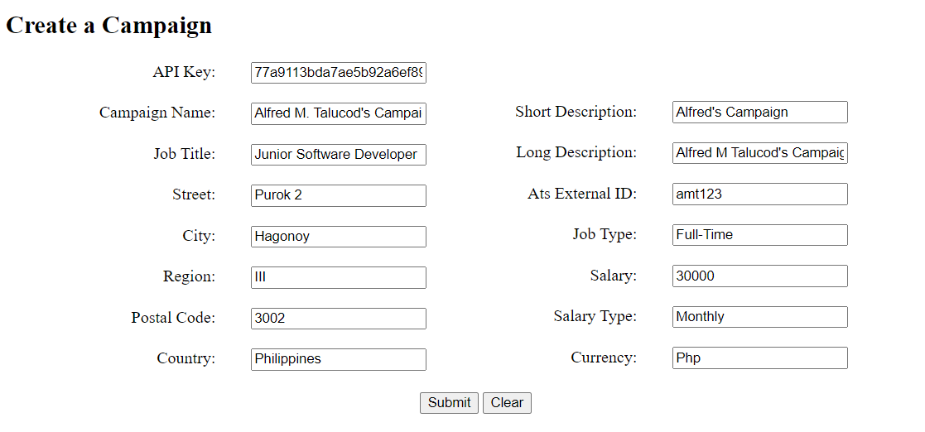
- Click on “Submit” button.

Results

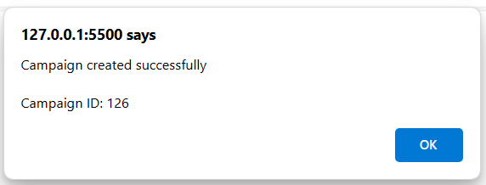
Campaign created successfully. Campaign ID:

Test Condition 2: Candidate Creation - All inputs are provided correctly.

Data Setup
- Provide all the required input parameters correctly

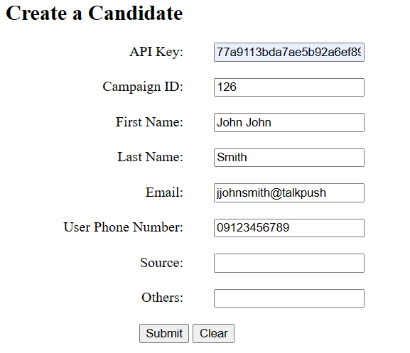
- Click on “Submit” button.

Results
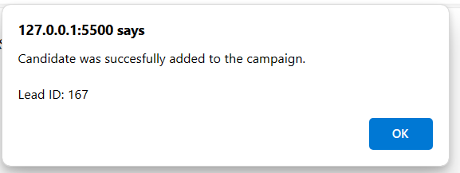
Candidate was successfully added to the campaign. Lead ID:

Test Condition 3: Retrieve a Candidate - All search criteria are provided correctly.

Data Setup
API key and Campaign ID was successfully fetched. 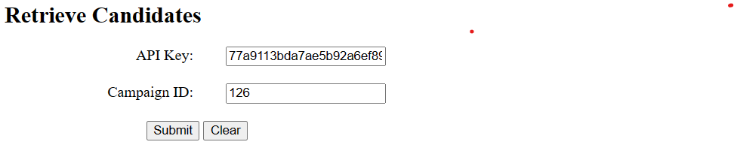

Results
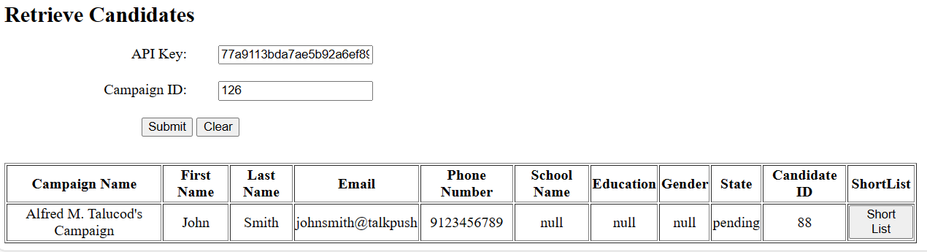
Table of all candidates in the campaign was showed successfully.

Test Condition 4: Shortlist a Candidate - All search criteria are provided correctly.

Data Setup
API key and Lead ID was successfully fetched.

Results
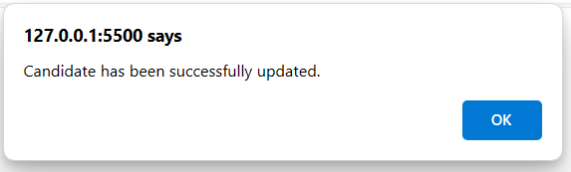
Candidate has been successfully updated.

Negative Test Cases

Test Condition 1: Campaign Creation – API Key provided was invalid.

Data Setup
  - Provide an invalid API key.
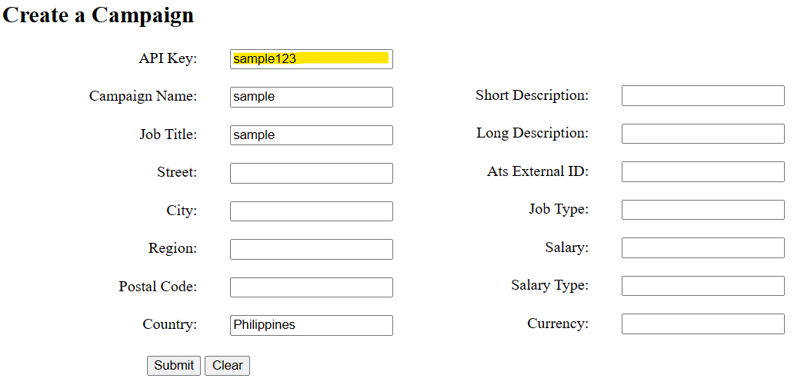

  - Click on “Submit” button.

Results
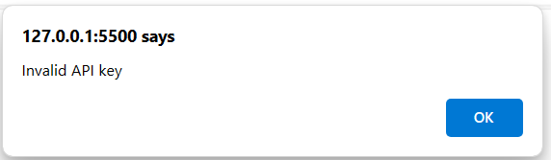
An error “Invalid API key” was raised.

Data Setup
  - Provide a blank API key.
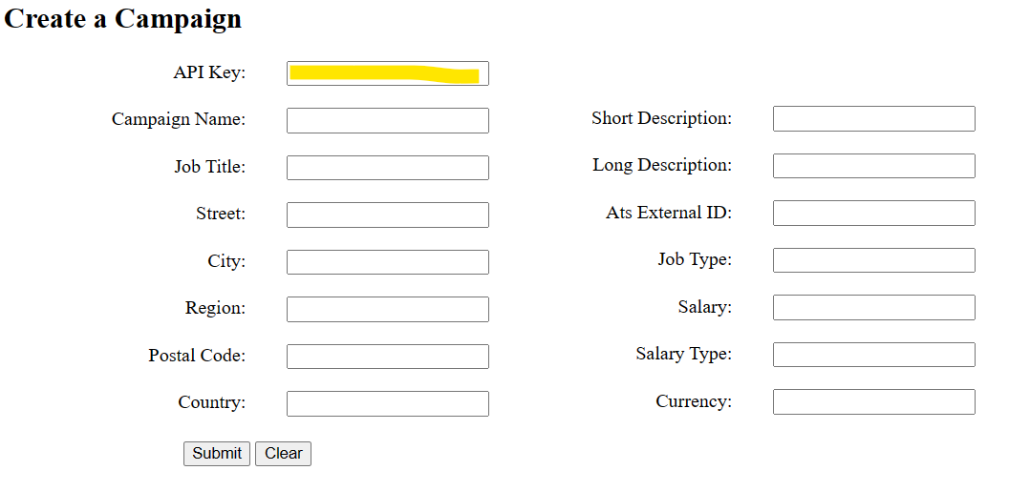

  - Click on “Submit” button.

Results
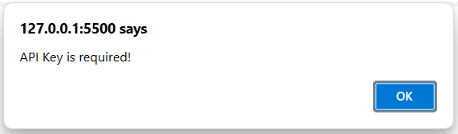
An error “API Key is required!” was raised.

Test Condition 2: Campaign Creation – Country was wrong.

Data Setup
  - Provide an invalid Country.

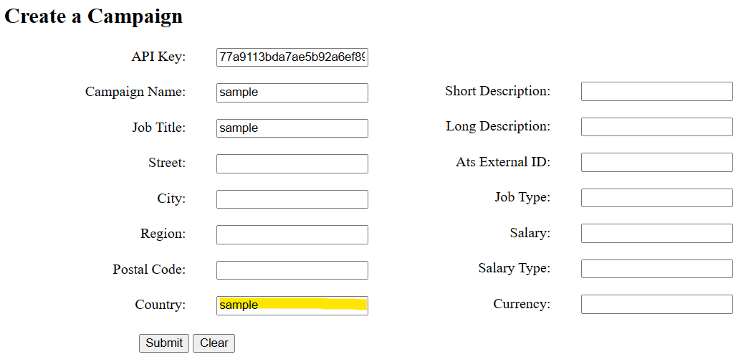
b. Click on “Submit” button.

Results
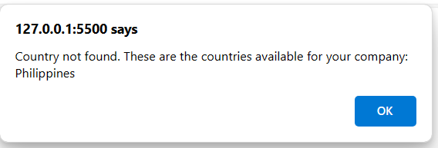
An error “Country not found. These are the countries available for your company: Philippines” was raised.

Data Setup
- Provide a blank Country.

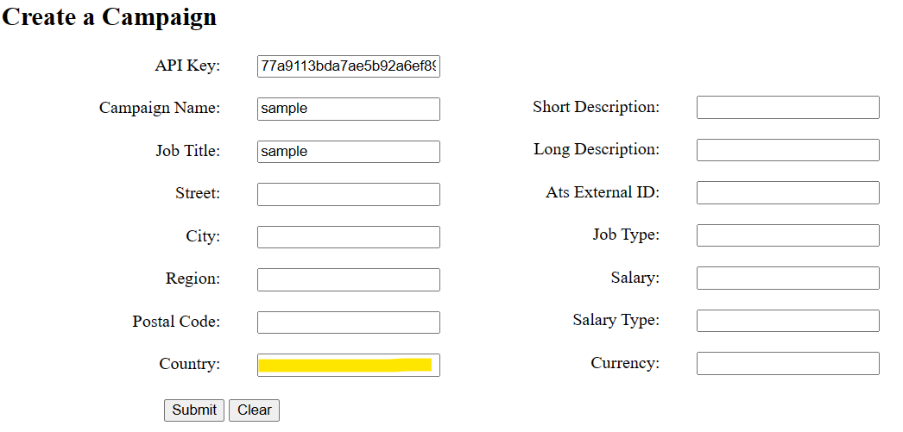
- Click on “Submit” button.

Results
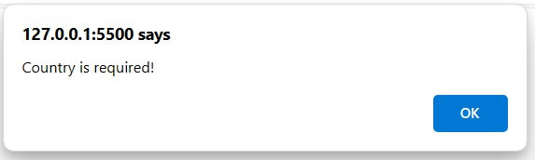
An error “Country is required!” was raised.

Test Condition 3: Campaign Creation – Campaign name was blank.

Data Setup
- Blank campaign name parameter.
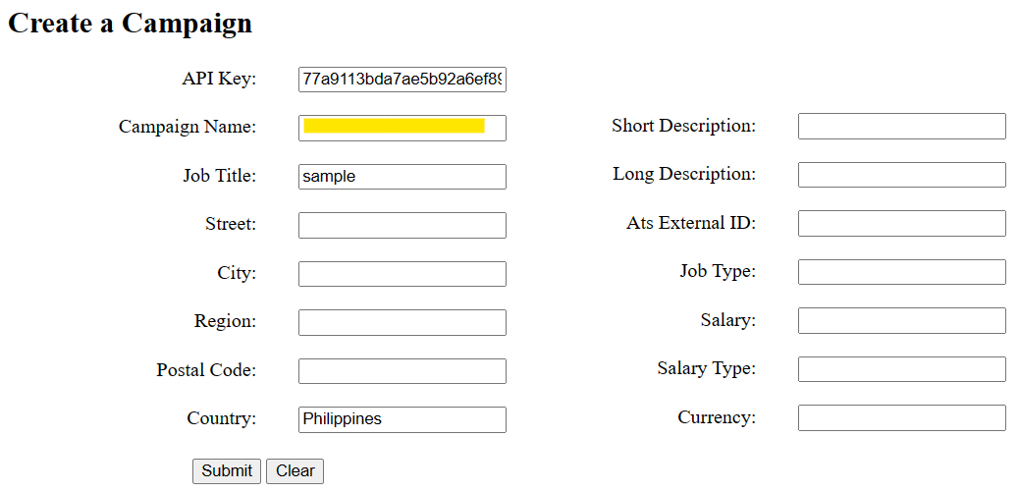
- Click on “Submit” button.

Results
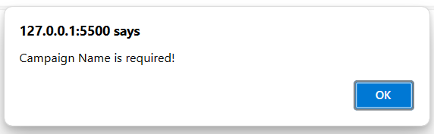

An error “Campaign name is required!” was raised.

Test Condition 4: Campaign Creation – Job Title was blank.

Data Setup
- Blank Job Title parameter.
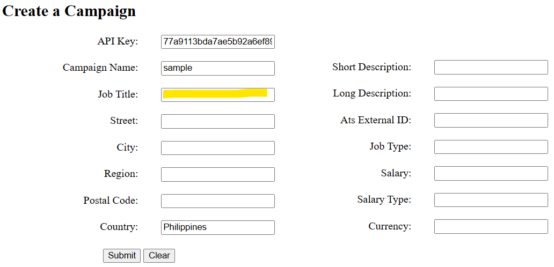
- Click on “Submit” button.

Results

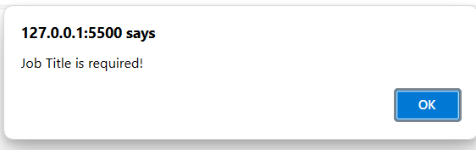
An error “Job Title is required!” was raised.

Test Condition 5: Candidate Creation – API key provided was wrong.

Data Setup
  - Provide an invalid API key.
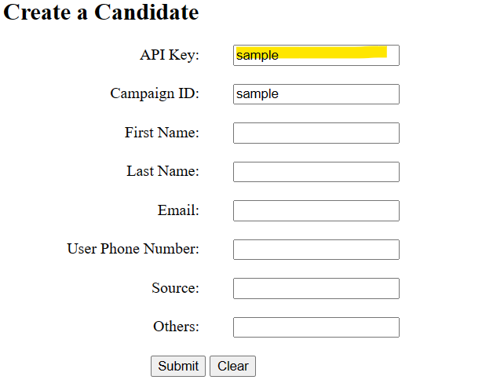
  - Click on “Submit” button.

Results

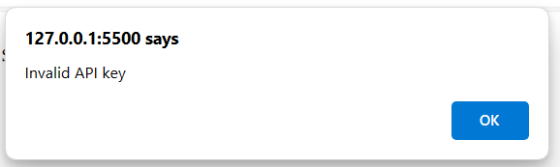
An error “Invalid API key!” was raised.

Data Setup
  - Blank API key.
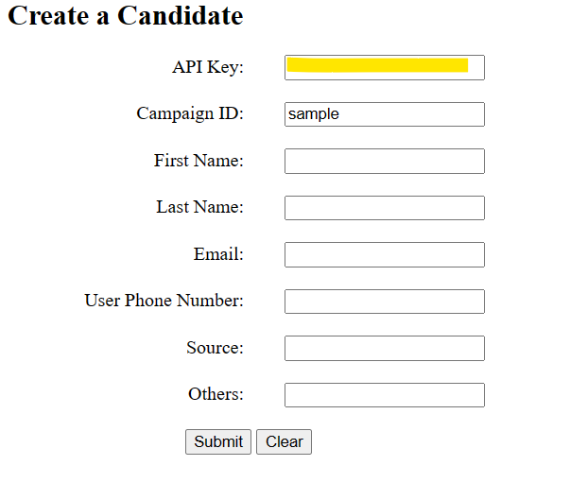
  - Click on “Submit” button.

Results

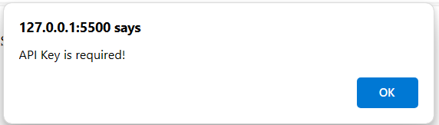
An error “APK key is required!” was raised.

Test Condition 5: Campaign Creation – Campaign ID was blank.

Data Setup
- Blank campaign ID parameter.
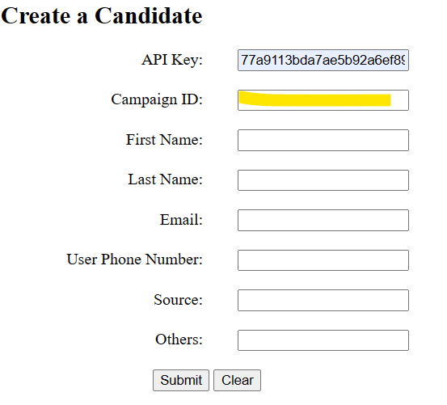
- Click on “Submit” button.

Results
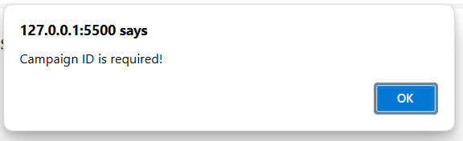
An error “Campaign ID is required!” was raised.

Test Condition 6: Campaign Creation – First name, email, user phone number was blank.

Data Setup
- First name, email, user phone number fields are blank.
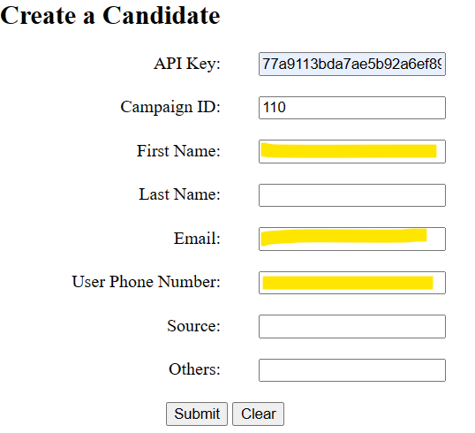
- Click on “Submit” button.

Results

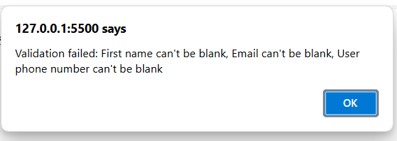
An error “Validation failed: First name can't be blank, Email can't be blank, User phone number can't be blank!” was raised.

Test Condition 7: Campaign Creation – First Name was blank.

Data Setup
- Blank first name parameter.
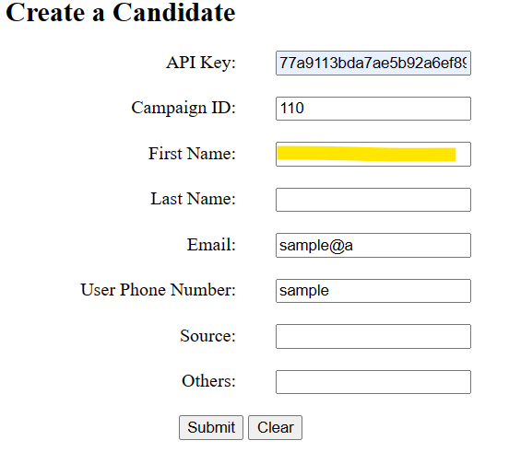
- Click on “Submit” button.

Results
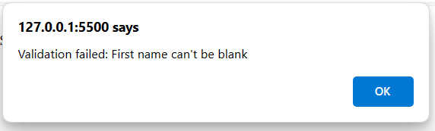
An error “Validation failed: First name can't be blank” was raised.

Test Condition 8: Campaign Creation – Email and user phone number was blank.

Data Setup
- Blank email and user phone number parameter.
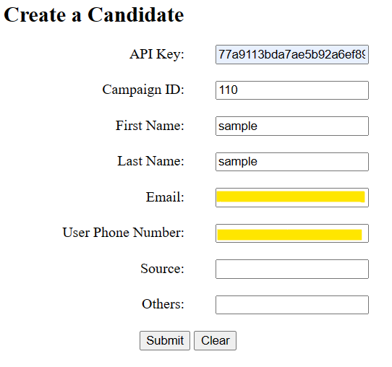
- Click on “Submit” button.

Results
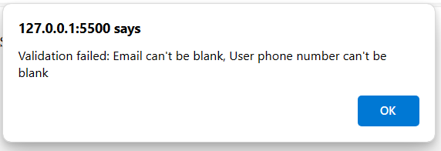
An error “Validation failed: Email can’t be blank, User phone number can’t be blank” was raised.

Test Condition 9: Campaign Creation – Email provided was wrong.

Data Setup
- Email provided was incorrect.
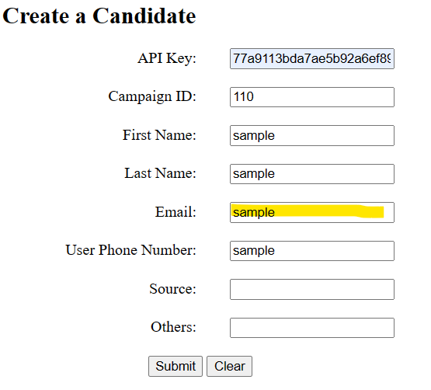
- Click on “Submit” button.

Results
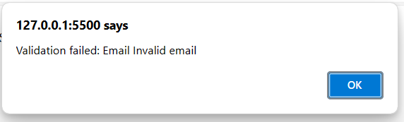
An error “Validation failed: Email Invalid email” was raised.

Test Condition 10: Retrieve a Candidate – API key provided was wrong.

Data Setup
- API key provided was incorrect.
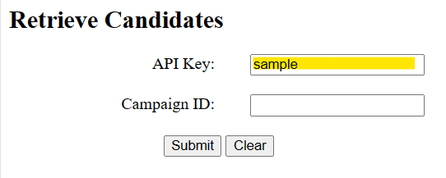
- Click on “Submit” button.

Results
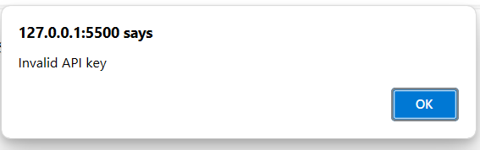
An error “Invalid API key” was raised.

Test Condition 11: Retrieve a Candidate – Campaign ID provided was wrong.

Data Setup
- Campaign ID provided was incorrect.
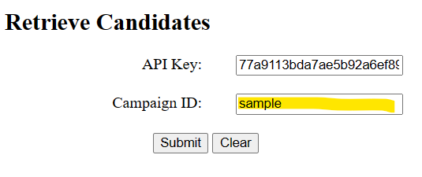
- Click on “Submit” button.

Results
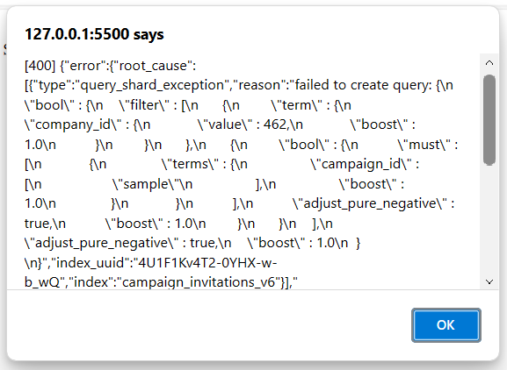
An error “Error 400” was raised.

